Adroit –Production Dashboard

- Production Performance Overview
🎯 Today’s & Weekly overview Panel
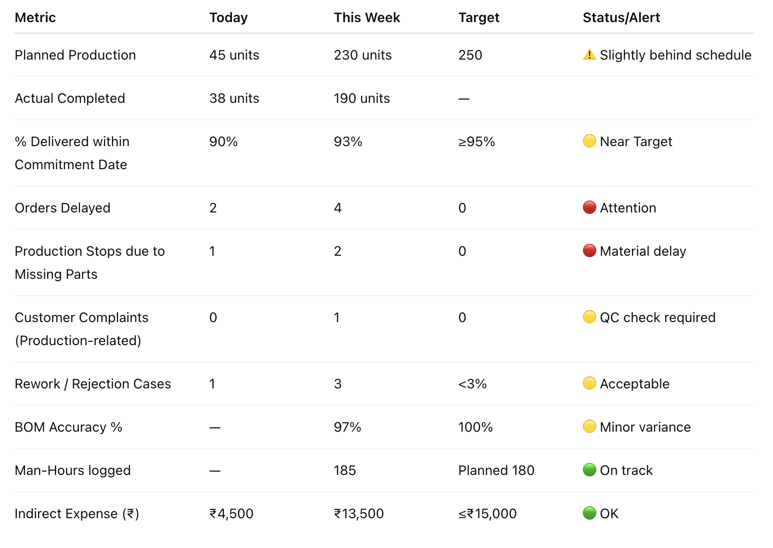
📊 Graphs & Tables
Delivery & Commitment Tracking
Graph 1: 📈 Planned vs Actual Production (Weekly)
- Line chart (Planned vs Actual)
- Tooltip: shows weekly delay %
Graph 2: 🟢 On-Time Delivery Trend
- Line graph: weekly on-time % vs target line (95%)
Table: Order Commitment & Delay Status
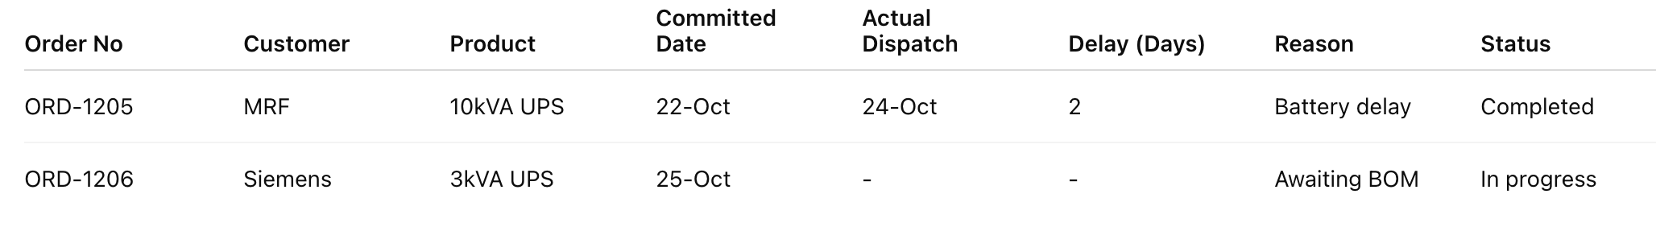🔔 Alerts:
- Orders delayed >2 days
- BOM not released for an active order
- Design pending for customer request > 1 day
- Quality, Complaints & Rework Panel
- Purpose: Quality and improvement visibility.
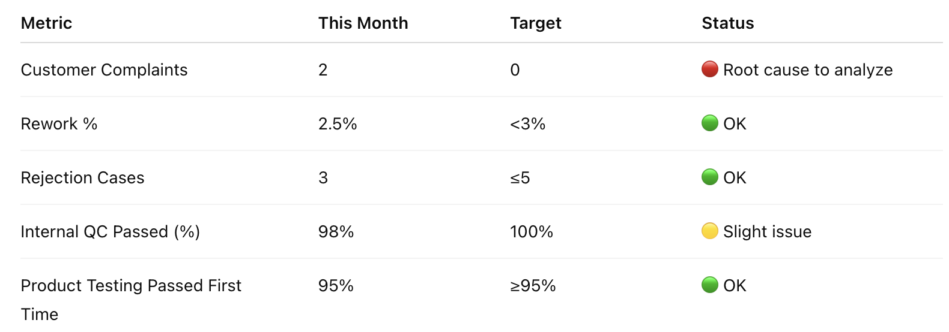
Charts:
- 📊 Complaints by Type – Pie chart (Wiring loose, finish issue, etc.)
- 📉 Rework Trend – Weekly bar chart showing % and units reworked

- Material, BOM & Inventory Control
Purpose: Material availability, BOM accuracy, and stock efficiency.
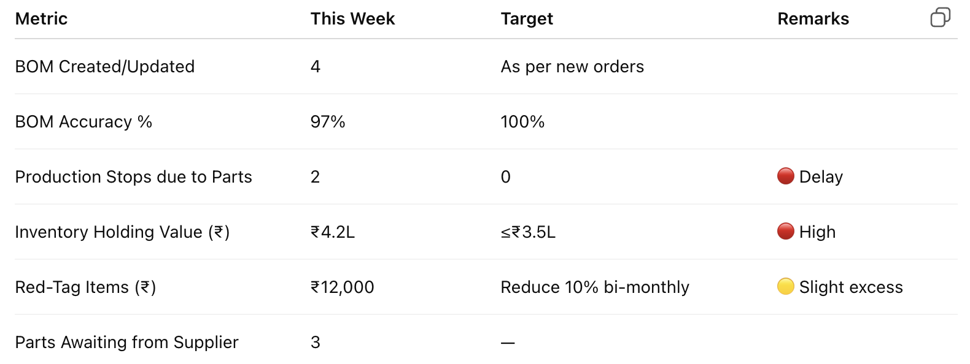
Charts:
- 📊 Inventory Holding vs Target – Bar graph
- 📈 Material Shortage Trend – Line chart
- 🧾 Top 5 Red-Tag Items by Value – Table

- Maintenance & Indirect Expenses
🛠️ Maintenance KPI Panel
Activity | Frequency | Completed | Remarks | Status
Machine Maintenance | 3 months | ✅ 2 |  | 🟡
Vehicle Service | 2 months | ✅ 3 |  | 🟢
Tools Inspection | Monthly | ✅ 12 |  | 🟢
Calibration | Monthly | ✅ 8 |  | 🟡
Preventive Maintenance | Monthly | ✅ 7 |  | 🟡
Chart: Maintenance Compliance % (Bar: Target vs Achieved)
🔔 Alerts:
- Maintenance overdue
- Tool inspection not logged
- Calibration report missing

- Indirect Expenses Tracker (separate for product and overall dept )
In Tiles
Metric | Value | Indicator
Average Indirect Cost % per Product | 7.1 % | 🟢 Good
Highest Indirect Expense Product | UPS 10 kVA (₹ 3,800) | 🔺 Attention
Total Indirect Cost This Month | ₹ 12,500 | 🟡 Neutral

This month products and its indirect expenses
Order No | Product | Man-Hours | Labour Cost (₹) | Transport (₹) | Cutting (₹) | Powder Coating (₹) | Other Outsource (₹) | Total Indirect Cost (₹) | % of Order Value
ORD-1205 | UPS 10 kVA | 12 | 1,800 | 800 | 500 | 700 | 0 | 3,800 | 8%
ORD-1206 | Control Panel 15 HP | 9 | 1,350 | 1,000 | 0 | 600 | 400 | 3,350 | 6%
ORD-1207 | Battery Charger 5 A | 6 | 900 | 400 | 0 | 300 | 0 | 1,600 | 5%

Overall dept total indirect expenses

Expense Type | This Month (₹) | Last Month (₹) | Variance % | Trend
Transport | 6,000 | 5,200 | +15% | 🔺
Cutting | 2,000 | 2,100 | -5% | 🔻
Coating | 3,000 | 2,900 | +3% | 🔺
Other Outsource | 1,500 | 1,200 | +25% | 🔺
Total | 12,500 | 11,400 | +9.6%

- Inventory & Material
KPI | Description | Target | Alert
Inventory Holding Value (₹) | Total value of stock | < ₹5L | Red if >₹50k
Holding Days | Avg inventory age | < 30 days | Red if >65
Material Shortages | Orders affected | 0 | Alert if >0
Graph: Inventory Holding Trend + Alert for aging > 60 days

- Improvement, Training & Risk Management
Purpose: Build continuous improvement and staff skill growth.
Metric | This Month | Target | Status
Kaizen / Six Sigma Activities | 2 | ≥2 | 🟢 Achieved
Design Improvements | 1 | ≥1 | 🟢 OK
Internal Training Conducted | 1 | ≥1 | 🟢 Done
External Training | 0 | 1 | ⚠️ Plan next month
Training Expenses (₹) | ₹2,000 | —
Risk Items Updated | 4 | All | 🟢 Done

📈 Chart: Improvements Implemented vs Cost Savings
📊 Risk Matrix (Heat Map):
High / Medium / Low risk visual summary

- Individual KPI & Team Evaluation
KPI | Formula / Definition | Target | Current | Status
% Orders Delivered on Time | Orders on time ÷ Total orders | ≥95% | 93% | 🟡
% Designs Released on Time | Released before commit ÷ Total | ≥95% | 90% | 🟡
BOM Accuracy | (Accurate BOM ÷ Total BOM) | 100% | 97% | 🟡
Rework % | Reworked ÷ Total produced | ≤3% | 2.5% | 🟢
No. of Improvements | Total Kaizen/Six Sigma entries | ≥2/mo | 2 | 🟢
Training Conducted | Internal + External | ≥1/mo | 1 | 🟢
Preventive Maintenance Compliance | Completed ÷ Planned | 100% | 90% | 🟡
Stoppages due to Missing Parts | Count | 0 | 2 | 🔴
Manhour Variance | (Actual–Planned)/Planned | ≤±10% | +5% | 🟢
Indirect Expense Control | Actual vs Budget | ≤Budget | 102% | 🟡
Red Tag Reduction | Value reduction % | ≥10% | 8% | 🟡
Submission Timeliness | Reports on time | 100% | 90% | 🟡
Accuracy of Reports | Owner verification | ≥95% | 94% | 🟡

KPI Graphs:
- Radar Chart: Overall KPI performance
- Trend Line: On-Time %, BOM Accuracy %, Rework % over last 3 months

- Smart Automation & Reports
🔔 Auto Alerts
- 🔴 “Product delay > 3 days – escalate to Director.”
- ⚠️ “Tools inspection overdue.”
- 🟢 “Training completed – October batch.”
- 🔴 “Inventory holding cost exceeds ₹6L.”

📧 Weekly Report (Auto-mail):
Sent every Monday morning to Owner & Production Head.
Includes KPI table, key graphs, pending alerts, improvement summary.

Changes required in field
- product delivery within the committed date check if it is there, add a KPI to the head for the same
- customer complaint due to production like wiring lose connection, Quality check
- Tools inspection done monthly or not check
- Internal and external training for production people given or not and expenses for the same
- if there any production stop or production delay due to of non-availability of item.
- individual performance report submitted for each production people by the head (KPI as well as should be added in the field)
- Risk Matrix if required
- Six sigma and Kaizen include as field as well KPI for individual
- Man hours calculation for each product entered by production head
- Machine (3 months once) , Vehicle Maintenance(2 months once), Tools check (monthly once), Periodic main, Preventive, calibrations is been done by production head- record if missing.
- indirect expense like transportation , if there is any box which we need a single cutting charges and powder coating charges we take the product go and get it done from our fabricator.
- Inventory holding alert and expense calculation shown in dashboard.
- Priority is set to each order so that the project I taken up first for production

